**Video Game Sales Project**

**The provided dataset appears to be a collection of video game sales data, containing various attributes related to video games such as title, platform, year of release, genre, publisher, sales figures across different regions, critic scores, user scores, developer, and rating.**

**Here's a breakdown of the dataset attributes:**

**Index: An index or identifier for each game entry.**

**Name: The title or name of the video game.**

**Platform: The gaming platform (e.g., Wii, Xbox, PlayStation) on which the game was released.**

**Year_of_Release: The year when the game was released.**

**Genre: The genre or category of the game (e.g., sports, racing, action).**

**Publisher: The company or entity that published or released the game.**

**NA_Sales, EU_Sales, JP_Sales, Other_Sales, Global_Sales: Sales figures for the game in different regions (North America, Europe, Japan, Other regions, and total global sales).**

**Critic_Score: The aggregated score given to the game by critics.**

**Critic_Count: The number of critics who provided scores for the game.**

**User_Score: The aggregated score given to the game by users or players.**

**User_Count: The number of users who provided scores for the game.**

**Developer: The company or individual responsible for developing the game.**

**Rating: The rating assigned to the game (e.g., E for Everyone, T for Teen, M for Mature).**

**This dataset can be used for various analytical purposes, including:**

**Analyzing the sales performance of games across different platforms, genres, and regions.**

**Identifying trends in gaming preferences over time.**

**Investigating the relationship between critic/user scores and sales performance.**

**Assessing the impact of developer/publisher on game sales and reception.**

**Exploring correlations between various attributes such as genre, platform, and sales figures.**

**Q1. Regional Sales Analysis: How do sales vary across different regions (NA, EU, JP, Other)?**

SELECT

SUM(NA_Sales) AS NA_Sales,

SUM(EU_Sales) AS EU_Sales,

SUM(JP_Sales) AS JP_Sales,

SUM(other_sales) AS Other_Sales

FROM

video_games;

**output-**

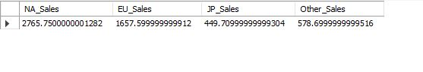

**Q2.Genre Performance Over Time:How have different genres performed over the years?**

SELECT

Genre, ROUND(SUM(global_sales), 2) AS total_sales

FROM

video_games

GROUP BY genre

ORDER BY total_sales DESC;

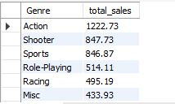

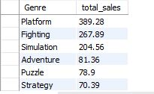

**Q3. Publisher Analysis: Which publishers have the most games in the dataset,**

**and what is the average sales performance of their games?**

SELECT

Publisher,

COUNT(name) AS total_games,

ROUND(AVG(Global_sales), 2) AS avg_sales_in_Million

FROM

video_games

GROUP BY publisher

ORDER BY total_games DESC;

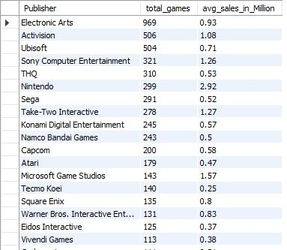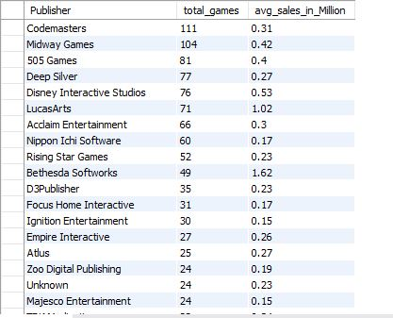

**Q4. Which publisher has released the most games?**

SELECT

Publisher,

COUNT(*) AS num_games

FROM

video_games

GROUP BY

Publisher

ORDER BY

num_games DESC

LIMIT 1;

**Output-**

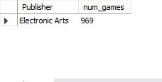

**Q5. What is the trend of video game sales over the years?**

SELECT

year_of_release, ROUND(SUM(global_sales), 2) AS total_sales

FROM

video_games

GROUP BY year_of_release

ORDER BY year_of_release ASC;

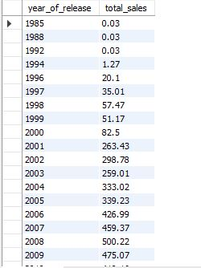

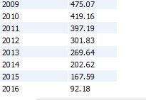

**Q6.How do user scores compare to critic scores on average?**

SELECT

AVG(User_score), AVG(critic_score)

FROM

video_games;

output -

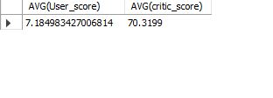

**Q7. Is there a relationship between developer and sales performance?**

SELECT

developer, round(SUM(global_sales),2) AS total_sales

FROM

video_games

GROUP BY developer

ORDER BY total_sales DESC;

Output -

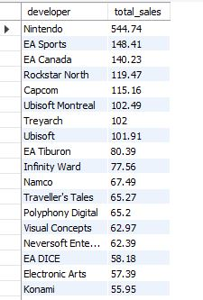

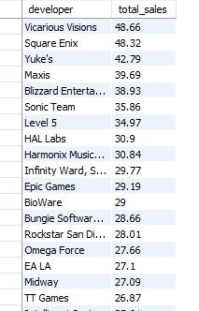

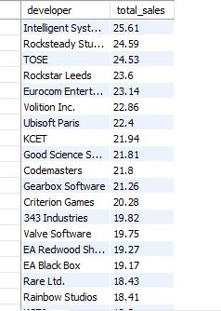

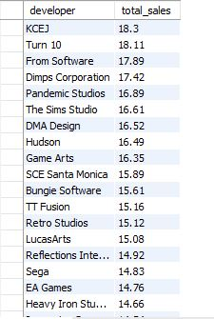

**Q8.Are there any notable patterns in the release dates of successful games?**

SELECT

year_of_release,

ROUND(SUM(global_sales), 2) AS total_sales,

COUNT(name) AS games_count

FROM

video_games

GROUP BY year_of_release

ORDER BY total_sales DESC;

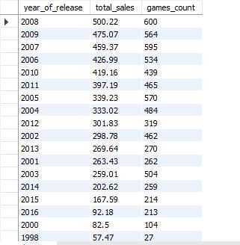

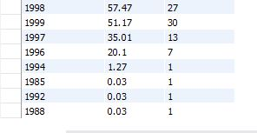

**Q9. What is the market share of each platform in terms of global sales?**

SELECT

platform,

ROUND(SUM(global_sales), 2) AS total_sales,

SUM(global_sales) / (SELECT

SUM(global_sales)

FROM

video_games) * 100 AS market_share

FROM

video_games

GROUP BY platform

ORDER BY market_share;

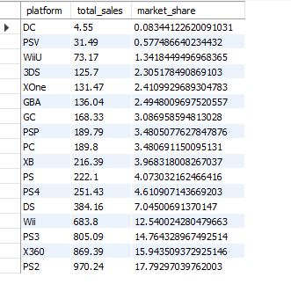

**Q10. What is the average lifespan of a video game in terms of sales performance?**

SELECT

(YEAR(NOW()) - Year_of_Release) AS age,

AVG(Global_Sales) AS avg_sales

FROM

video_games

GROUP BY

age

ORDER BY

age;

